GITHUB PROJECT
Project Description
This project implements a structured Git workflow to streamline collaborative development at Black Grapes Softech. It uses GitHub/GitLab with well-defined branching strategies such as feature, develop, and release branches. Pull request reviews ensure code quality, while systematic merge conflict resolution supports smooth integration. The workflow provides full traceability of code changes, enabling reliable production deployments.

Requirements
- Two EC2 instance create for linux server, Master & Slave server.
- Master Server Installation – java , Jenkins
- Slave Server Installation – java, maven, tomcat Apache, Git
Github
- Login your github account
- Click Repositories Menu -> Click New button in right side
- Type the BlackGrapes in Repository name.
- Choose Private in Choose Visibility in configuration menu.
- Choose ON the Add README.
- Click Create Repository button.
- After click Add file button-> Click Upload files. Now add all files and folders.
- Choose commit directly to main branch. After click commit changes button.
- Or else after repository creation below the steps to upload the files and folders through bash command.
- Open the browser, search the keyword git click the first link. Click the link to download 64-bit Git for Windows Setup and install it in your system.
- Go to the project folder Click right-click -> Choose open Git Bash here
- Open Git Command Prompt
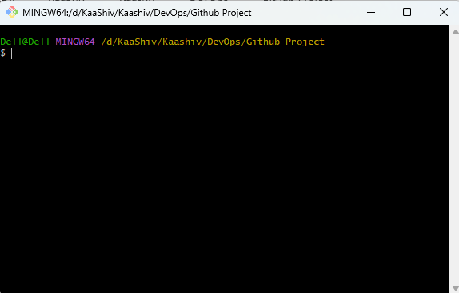
- Command is Intializes a new git repository in current directory.
git init
- Add the stages file for commit. He used . this dot to add all the files
git add .
- Commit the stages with the message
git commit -m BlackGrapes
- Open the main branch
git branch -M main
- Now add the destination place below the commands. The destination place github account url copy and paste it here.
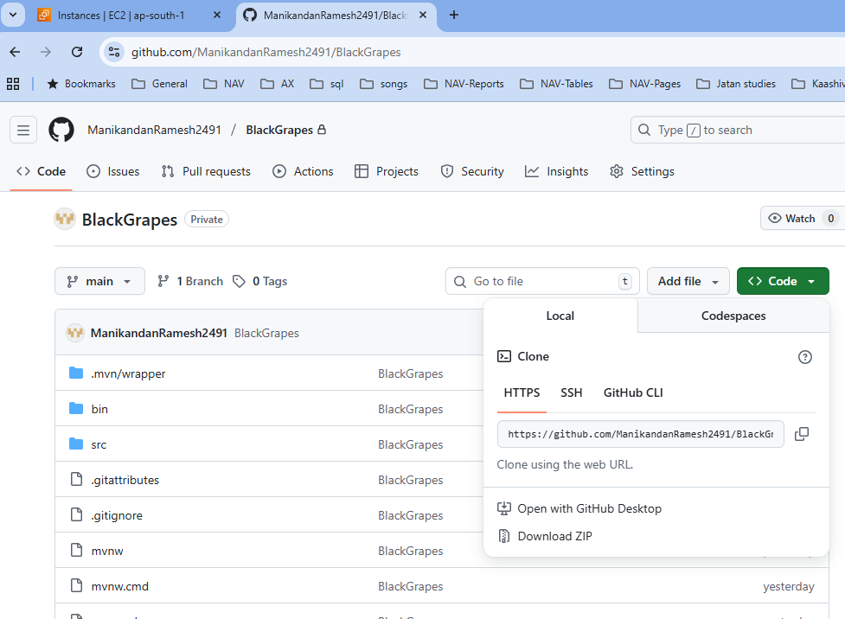
git remote add origin https://github.com/ManikandanRamesh2491/BlackGrapes.git

- Now push the changes from the local branch to remote repository.
git push -u origin main (or)
git push -u origin main --force
Master server
- Go to EC2 instance, click Launch Instance.
- Type Master in name.
- Choose Amazon Linux(AWS).
- Choose Amazon Linux 2023 kernel-6.1 AMI (Free tier) in Amazon Machine Image(AMI).
- Choose t3.micro in Instance type.
- Choose Mani_LinuxAM in Key pair name.
- In Network settings tab Click Edit -> Choose default vpc in VPC and select default security group in common security group.
- Finally Click Launch instance button.
- Now connect the instance and run it.

Slave server
- Go to EC2 instance, click Launch Instance.
- Type Slave in name.
- Choose Amazon Linux(AWS).
- Choose Amazon Linux 2023 kernel-6.1 AMI (Free tier) in Amazon Machine Image(AMI).
- Choose t3.micro in Instance type.
- Choose Mani_LinuxAM in Key pair name.
- In Network settings tab Click Edit -> Choose default vpc in VPC and select default security group in common security group.
- Finally Click Launch instance button.
Process started
- Run and Change the ec2-user to root user command in Master server
[ec2-user@ip-172-31-12-228 ~]$ sudo su -
- Package update command
- [root@ip-172-31-12-228 ~]# yum update –y
- Command is download the Jenkins file and save it in particular path
[root@ip-172-31-12-228 ~]# wget -O /etc/yum.repos.d/jenkins.repo \
https://pkg.jenkins.io/redhat-stable/jenkins.repo
- Import key file from Jenkins-CI to enable the installation from package
[root@ip-172-31-12-228 ~]# rpm --import https://pkg.jenkins.io/redhat-stable/jenkins.io-2023.key
- Key upgrade command
[root@ip-172-31-12-228 ~]# yum upgrade
- Download and Install java. This is need to support Jenkins
[root@ip-172-31-12-228 ~]# yum install java-21-amazon-corretto -y
- Now download and install the Jenkins below the command
- [root@ip-172-31-12-228 ~]# yum install jenkins -y
- Now enable the Jenkins
[root@ip-172-31-12-228 ~]# systemctl enable jenkins
- Now start the Jenkins
[root@ip-172-31-12-228 ~]# systemctl start jenkins
- Now check the status Jenkins
[root@ip-172-31-12-228 ~]# systemctl status Jenkins
- Run this command copy the administrator password.
[root@ip-172-31-12-228 ~]# cat /var/lib/jenkins/secrets/initialAdminPassword
- Copy the EC2 instance public ip and paste it into the browser and :8080 and run it. Now Jenkins installation page is open.
http://43.204.148.89:8080/
- Here will paste the admin password and Click Continue button
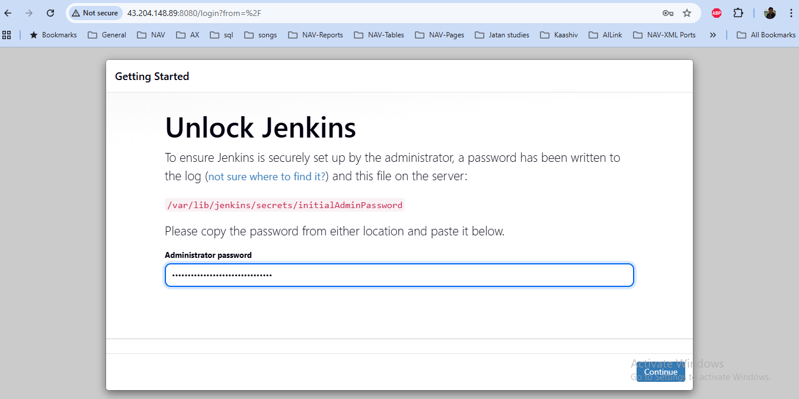

- Now Click install suggested plugin button
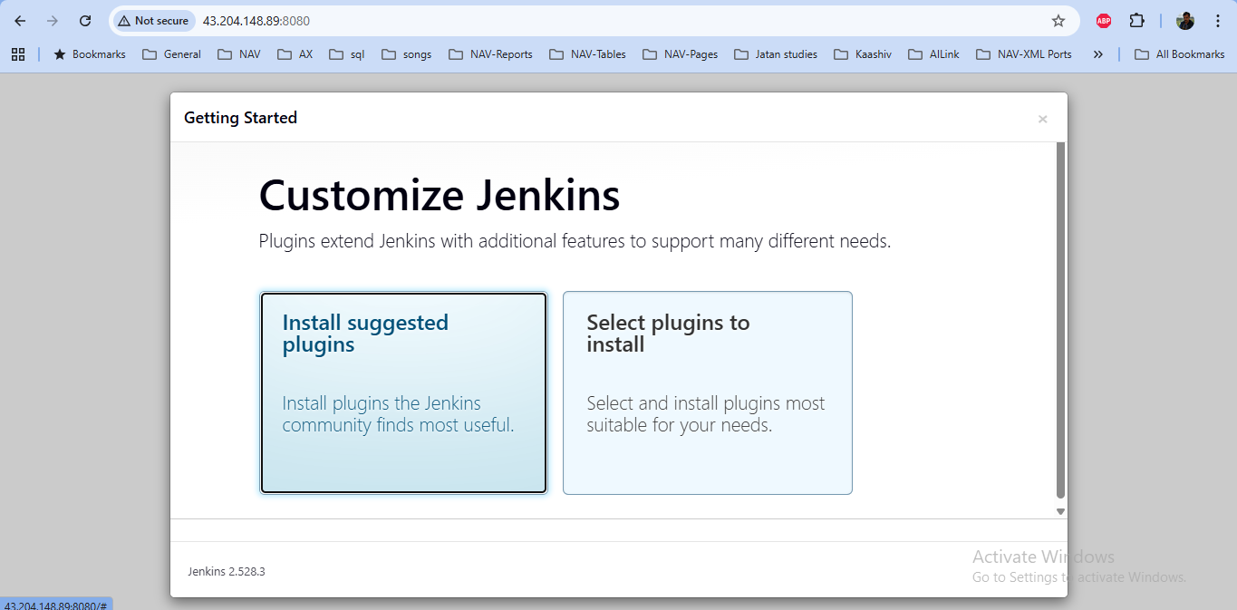

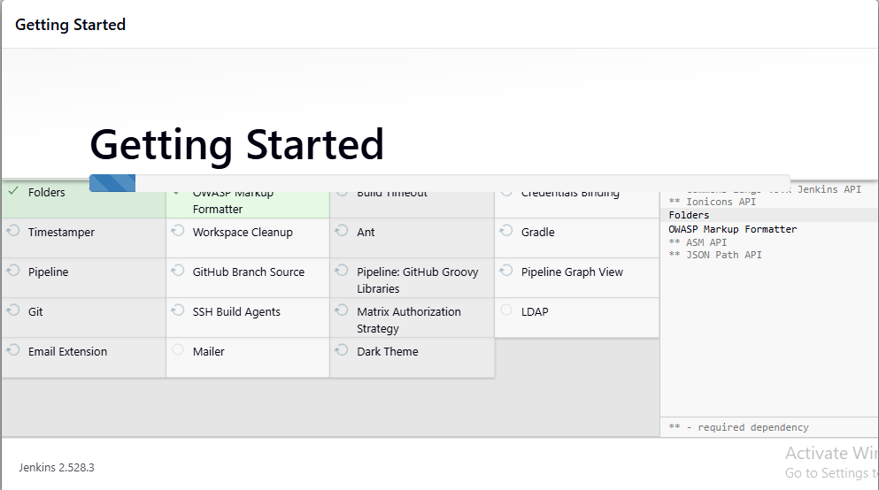
- Create first admin user page open. Here username admin and password admin123. Add your email id and fullname. Click save and continue button.
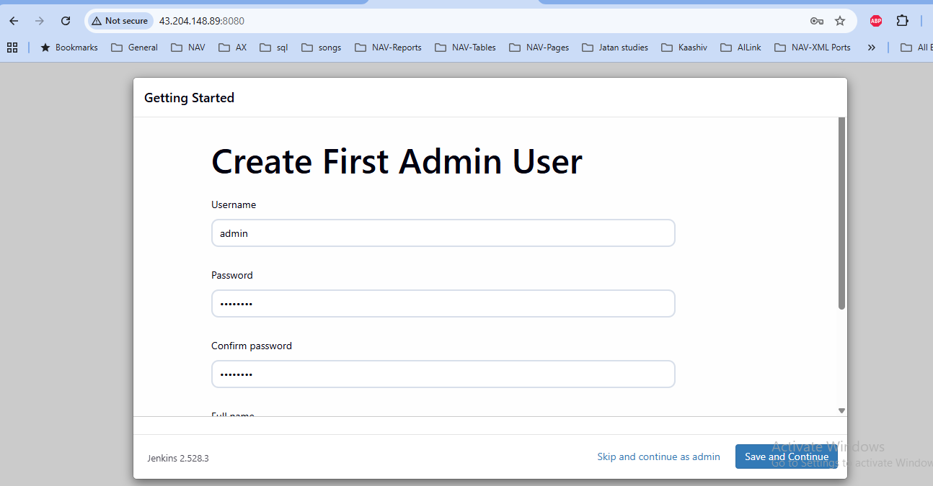

- Now instance configuration page is open. Here see the jenikins configuration url is showing and click save and finish button.
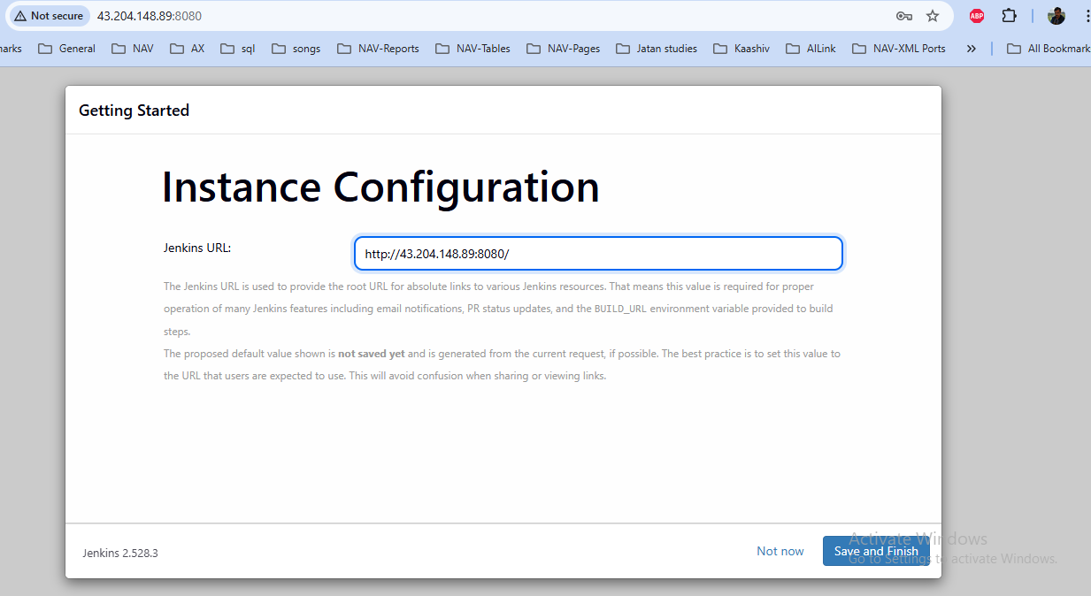
- Click start using Jenkins button
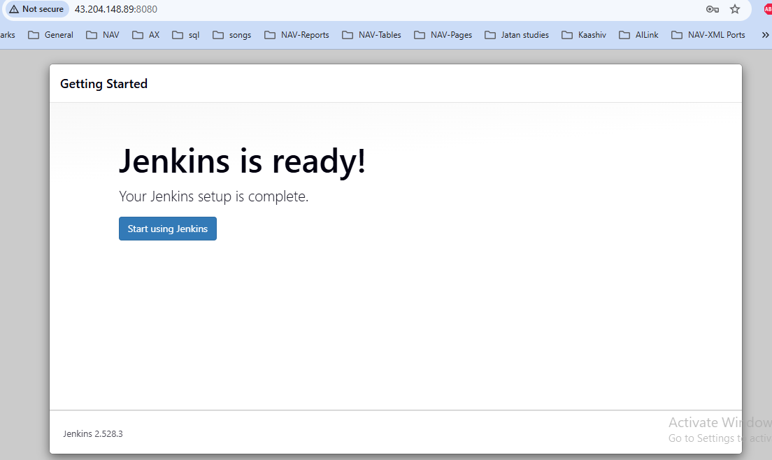

- Now Jenkins page is open
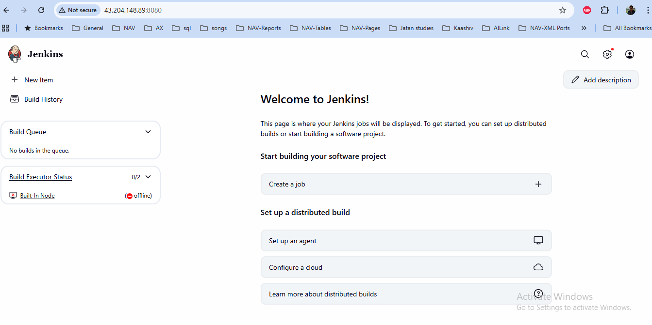
- Click Built in node is showing offline.
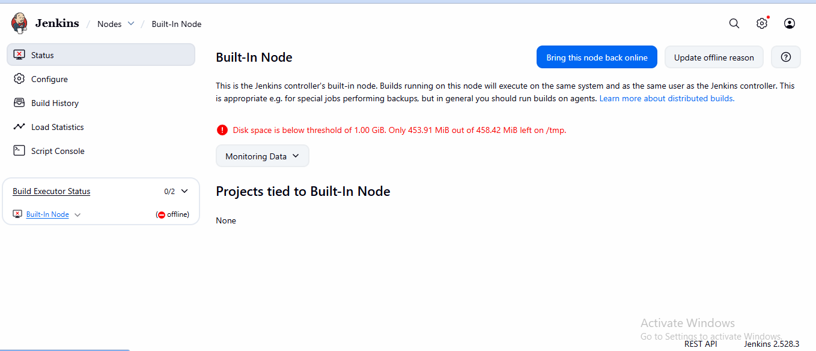
- In top menu click nodes. Automatically open the node page and click configure monitors button
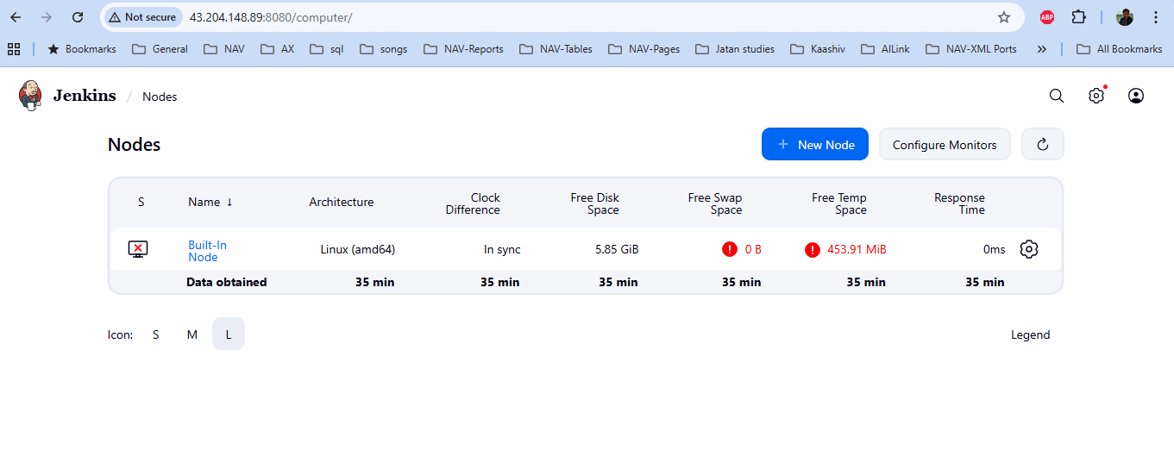
- Now configure node monitor page has opened. Now select the checkbox free disk space and free temp space and click save button
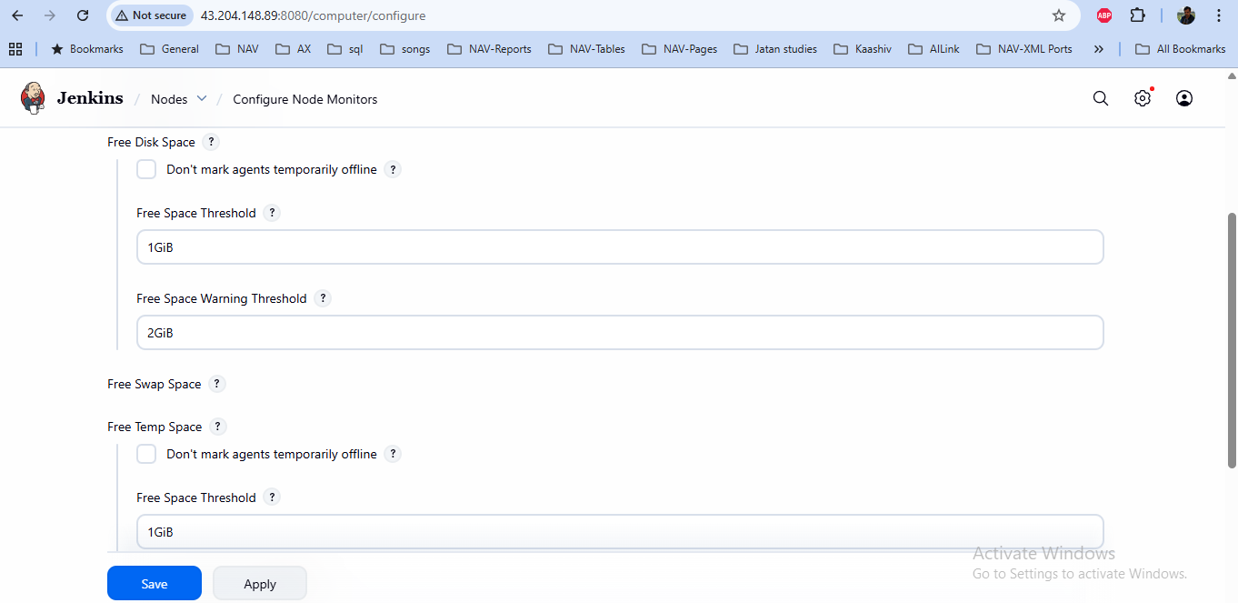
- Now click Built-in-Node link in left side.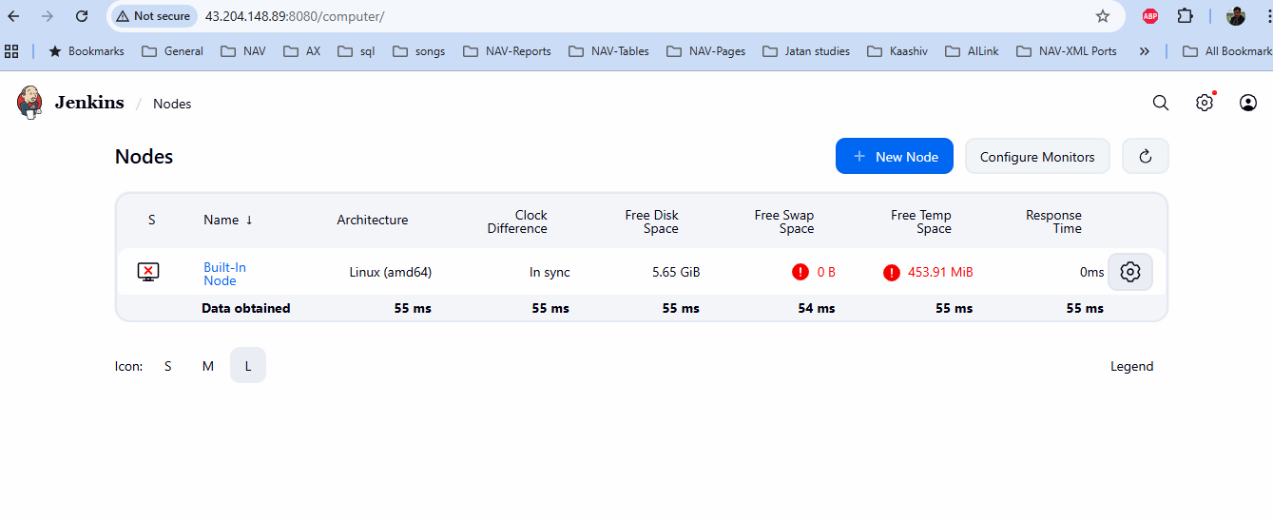
- Now click Bring this node back online button.
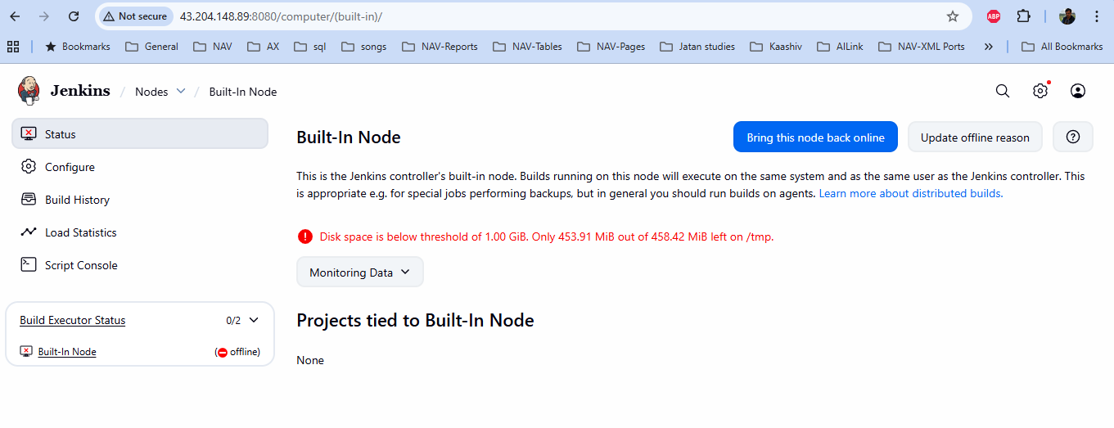
- Now disk space error in gone in Build in node
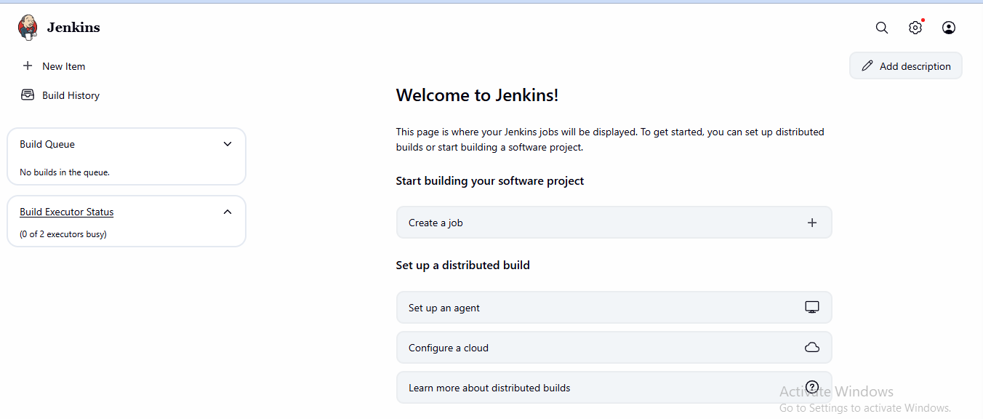
- Now we will go to connect master and slave ec2 instance. Now go top corner Click settings icon button and Manage Jenkins name is showing. After click Nodes
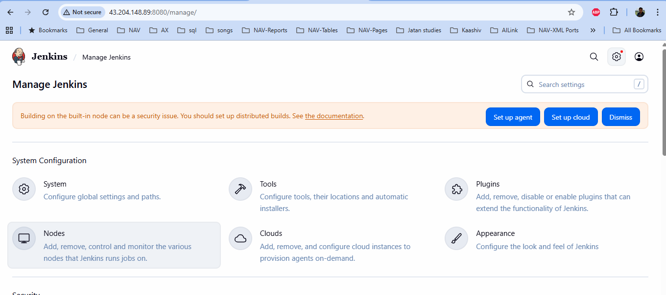
- Now Click New node button.
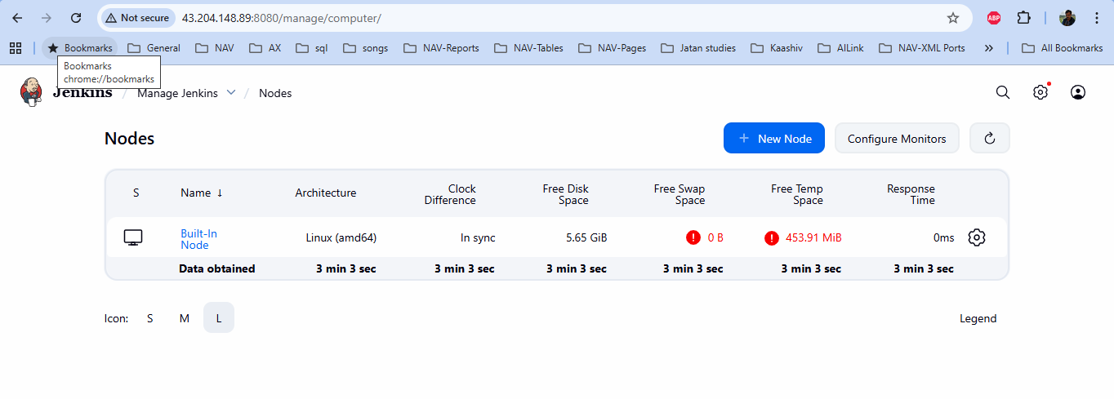
- Now Type the name is Slave for my Ec2 instance name. Select Permanent Agent and click Create button.
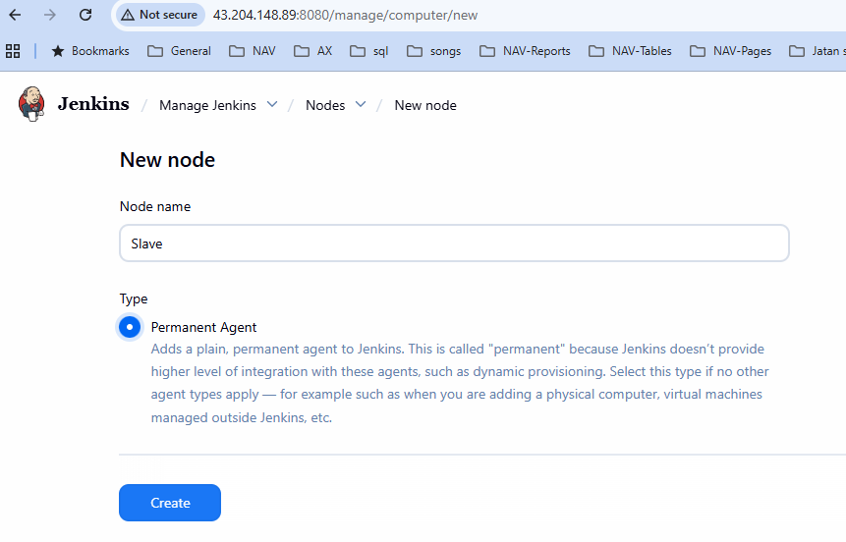
- Nodes Slave page is open. Now I can run and connect the Slave EC2 instance. Below the command to take the slave connect path
[ec2-user@ip-172-31-13-188 ~]$ pwd
- Create a new directory and take path step below the command
[ec2-user@ip-172-31-13-188 ~]$ mkdir Jenkins
[ec2-user@ip-172-31-13-188 ~]$ cd Jenkins
[ec2-user@ip-172-31-13-188 jenkins]$ pwd
/home/ec2-user/jenkins
- Now copy this path /home/ec2-user/jenkins and paste it in Remote root directory in Jenkins node slave page. Type the web-server in Labels.
- Now I want to generate the jar file for Slave server can copy the Private IP from Master EC2 instance and paste it below the command and check the ls command. This particular jar file will connect is Master & Slave server
[ec2-user@ip-172-31-13-188 jenkins]$ wget http://172.31.12.228:8080/jnlpJars/agent.jar
[ec2-user@ip-172-31-13-188 jenkins]$ ls
agent.jar
- Install java in Slave server. This install will be root server
[ec2-user@ip-172-31-13-188 jenkins]$ sudo su -
[root@ip-172-31-13-188 ~]# yum install java-21-amazon-corretto -y
- Now Go to jenkins node slave page Choose Launch agents via SSH in Launch method. Copy the Private ip in slave server and paste it 172.31.13.188 in Host.
- Now you will add the Credentials. Click Add button -> click Jenkins.
- Now add credentials page will open. Choose SSH Username with private key in kind. Type Slave in ID and Description.Type ec2-user in Username.
- Choose the option Private Key
- Now you have linux key pair file (.ppk). now run the putty gen and convert into the .PEM format. This .pem format file open in notepad.
- Now go to the credentials page and option private key and click add button and the pem format key file content copy and paste it here. After that click Add button.
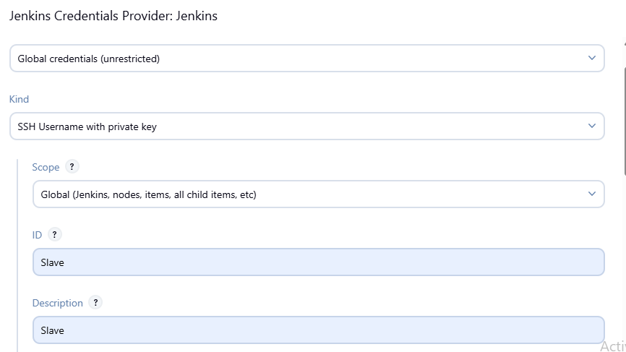
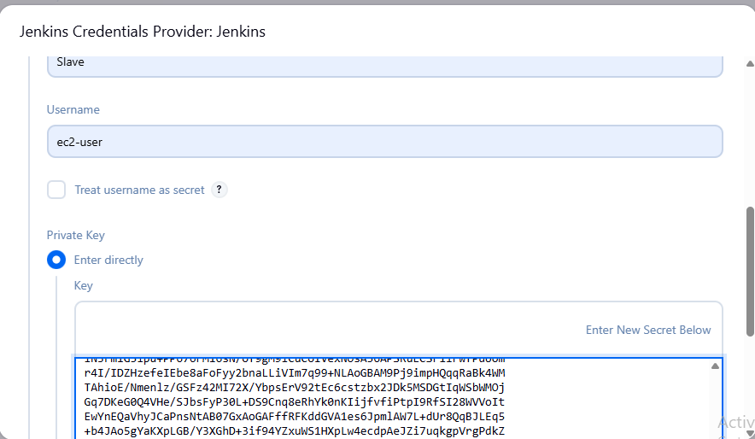

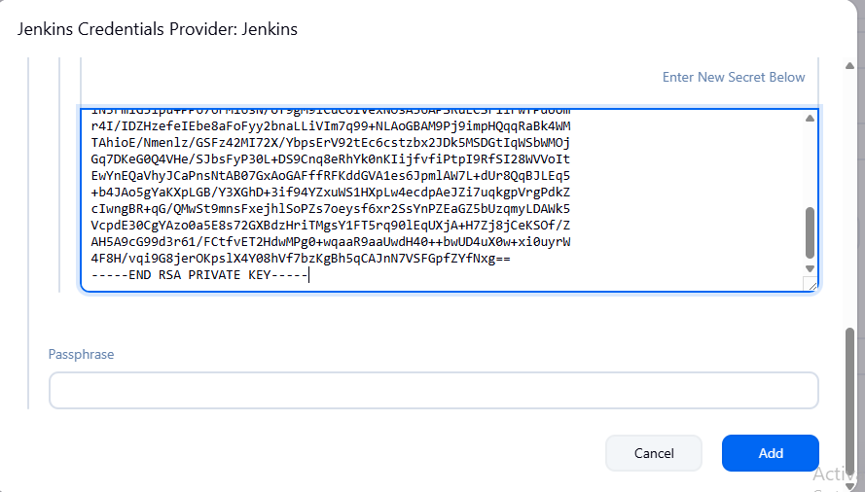
- Now Jenkins slave node page ec2-user (Slave) or -current- in credentials is showing
- Choose manually trusted key verification strategy in Host key verification strategy and click Save button.
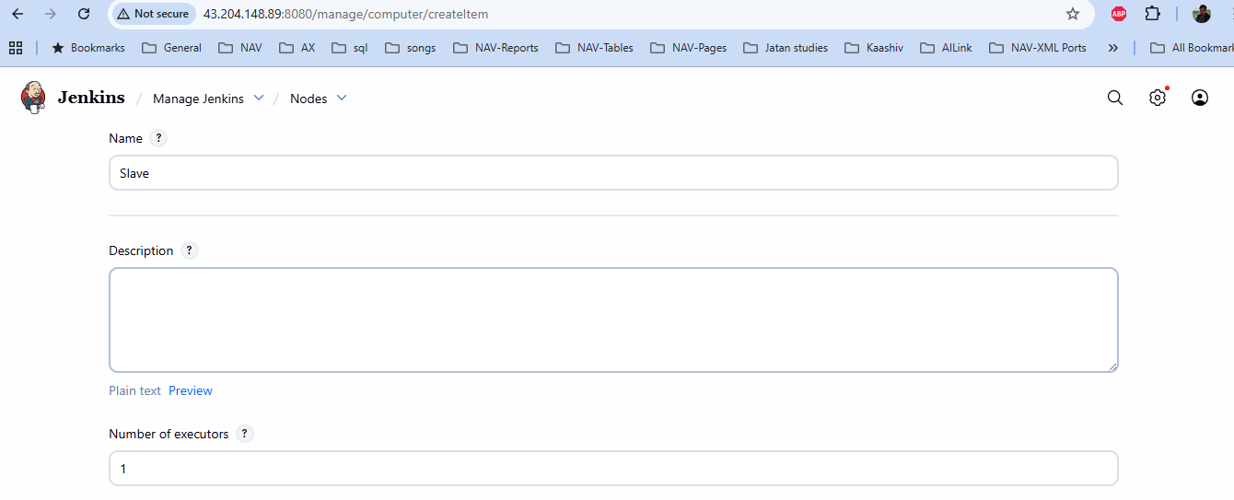
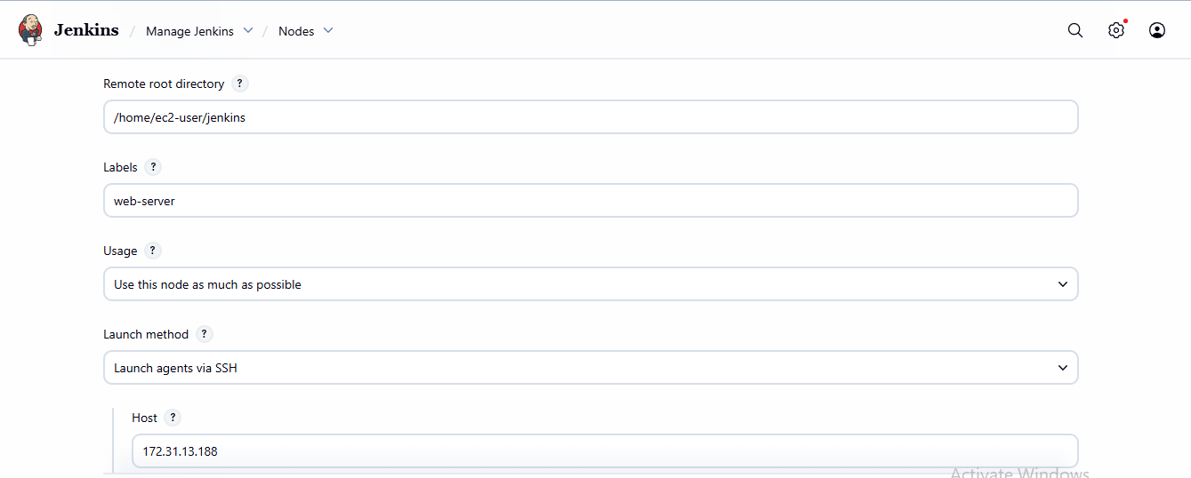

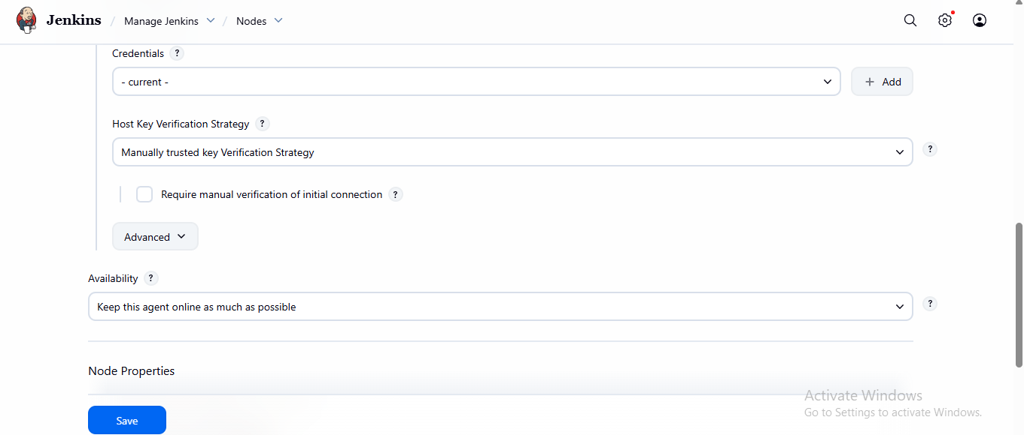
- Go to Slave node file and select log option. Here installation and Agent has successfully connected is showing
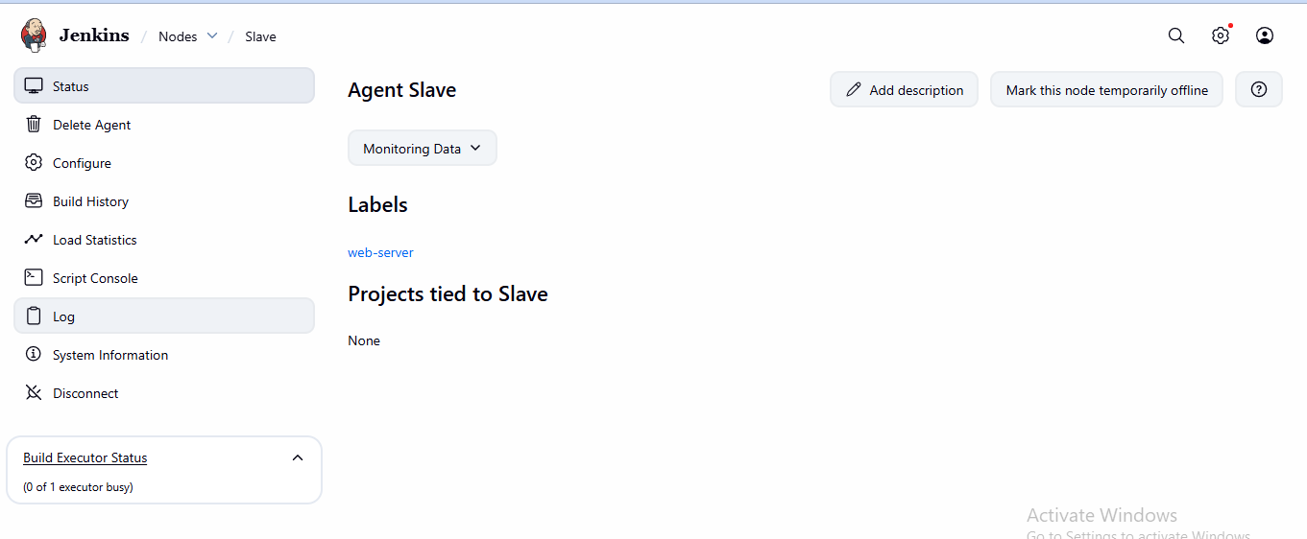
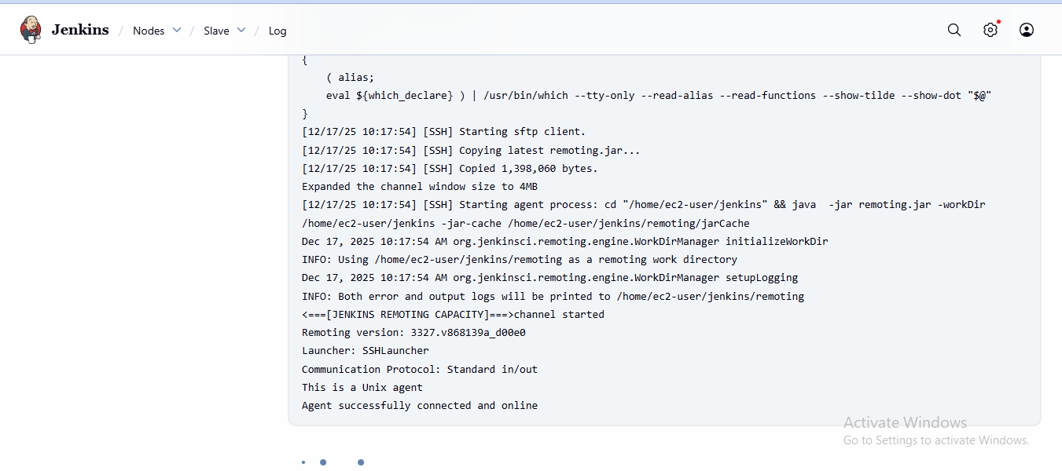
- Go to the Slave node free swap space and free temp space needed
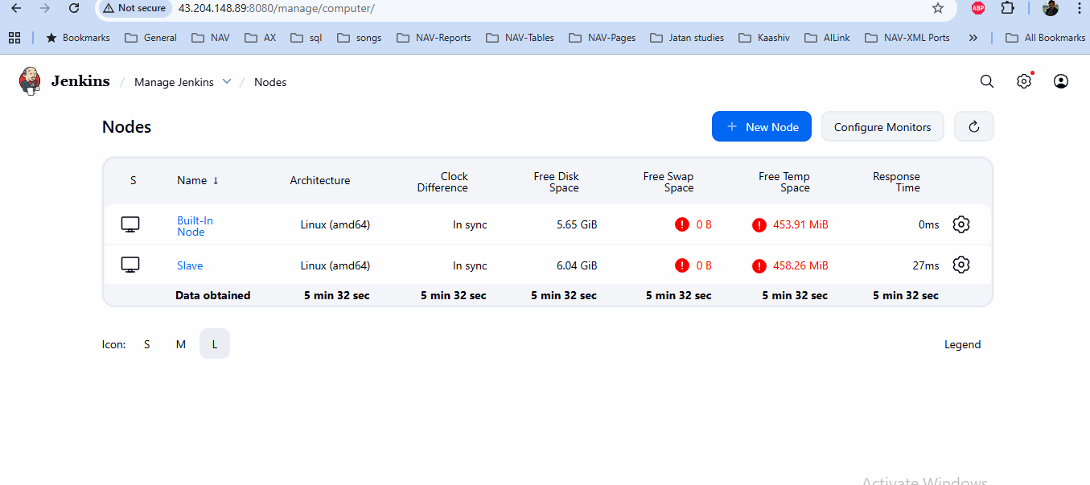
- Now we can run the command in Slave EC2 instance server to increase the swap & Temp space
root@ip-172-31-13-188 ~]# swapon --show
[root@ip-172-31-13-188 ~]# fallocate -l 4G /swapfile
[root@ip-172-31-13-188 ~]# dd if=/dev/zero of=/swapfile bs=1M count=4096
4096+0 records in
4096+0 records out
4294967296 bytes (4.3 GB, 4.0 GiB) copied, 31.0168 s, 138 MB/s
[root@ip-172-31-13-188 ~]# chmod 600 /swapfile
[root@ip-172-31-13-188 ~]# mkswap /swapfile
Setting up swapspace version 1, size = 4 GiB (4294963200 bytes)
no label, UUID=b740b779-de0e-4618-bc08-ff39d3327dbe
[root@ip-172-31-13-188 ~]# swapon /swapfile
[root@ip-172-31-13-188 ~]# swapon --show
NAME TYPE SIZE USED PRIO
/swapfile file 4G 0B -2
- Nano command using paste the content /swapfile swap swap defaults 0 0
[root@ip-172-31-13-188 ~]# nano /etc/fstab
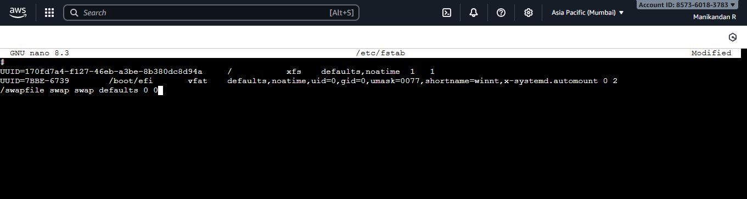
Now free swap space is coming
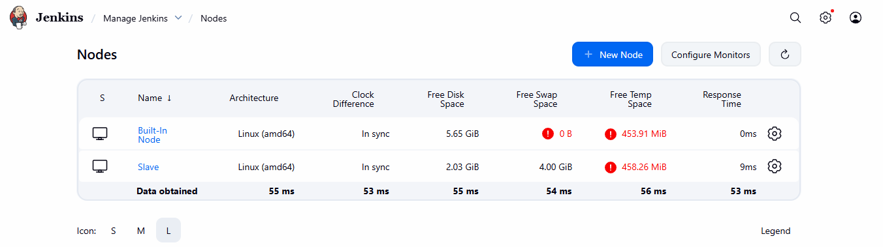

- Now increase the temp space code command
[root@ip-172-31-13-188 ~]# mount | grep /tmp
tmpfs on /tmp type tmpfs (rw,nosuid,nodev,seclabel,size=469424k,nr_inodes=1048576)
[root@ip-172-31-13-188 ~]# mount -t tmpfs -o size=2G tmpfs /tmp
- Nano command using paste the content /tmp tmpfs tmpfs size=2G,mode=1777 0 0
[root@ip-172-31-13-188 ~]# nano /etc/fstab
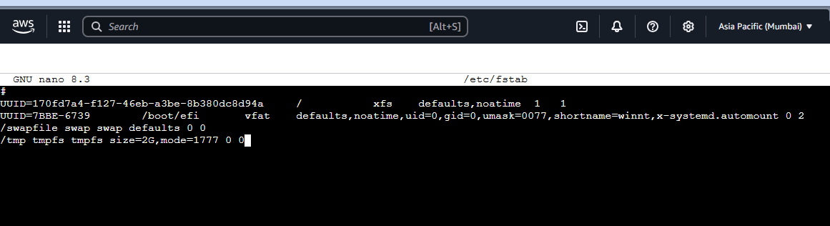
[root@ip-172-31-13-188 ~]# df -h
Filesystem Size Used Avail Use% Mounted on
devtmpfs 4.0M 0 4.0M 0% /dev
tmpfs 459M 0 459M 0% /dev/shm
tmpfs 184M 436K 183M 1% /run
/dev/nvme0n1p1 8.0G 5.9G 2.1G 75% /
tmpfs 2.0G 0 2.0G 0% /tmp
/dev/nvme0n1p128 10M 1.3M 8.7M 13% /boot/efi
tmpfs 92M 0 92M 0% /run/user/1000
- Now increase the space in both free swap & temp space.
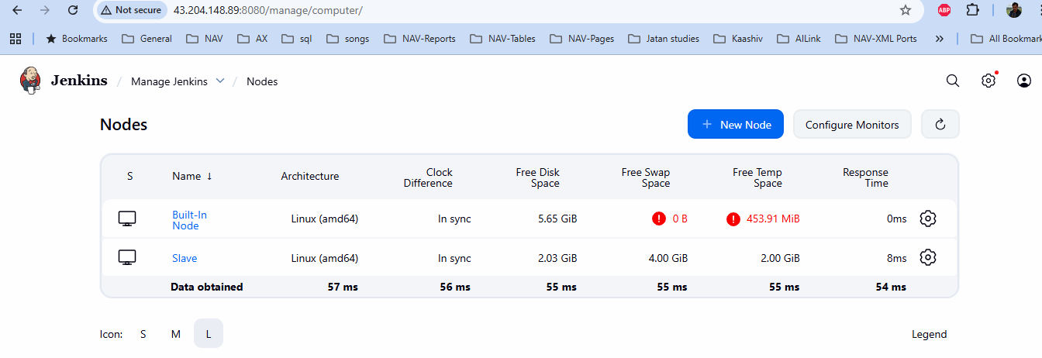

- Next all the installation in slave server only
- Now Maven installation. Now copy the maven installation link copy it from browser and paste it command. Copy the .bin.tar.gz link
[root@ip-172-31-13-188 ~]# wget https://dlcdn.apache.org/maven/maven-3/3.9.12/binaries/apache-maven-3.9.12-bin.tar.gz
- Extract the tar file
[root@ip-172-31-13-188 ~]# tar xzvf apache-maven-3.9.12-bin.tar.gz -C /opt
- Set the environment path command
[root@ip-172-31-13-188 ~]# echo 'export PATH=$PATH:/opt/apache-maven-3.9.12/bin' >> /root/.bashrc
source ~/.bashrc
- Check the maven version command
[root@ip-172-31-13-188 ~]# mvn -v
- Now tomcat installation. Now copy the maven installation link copy it from browser and paste it command. Copy the .tar.gz link under Binary distributions heading
- [root@ip-172-31-13-188 ~]# wget https://dlcdn.apache.org/tomcat/tomcat-10/v10.1.50/bin/apache-tomcat-10.1.50.tar.gz
- Extract the tar file
[root@ip-172-31-13-188 ~]# tar xzvf apache-tomcat-10.1.50.tar.gz -C /opt
- Set the environment path command
[root@ip-172-31-13-188 ~]# echo 'export PATH=$PATH:/opt/apache-tomcat-10.1.50/bin' >> ~/.bashrc
source ~/.bashrc
- Run the command tomcat is working
[root@ip-172-31-13-188 ~]# startup.sh
- Now copy the Public IP from server and run the http link format in browser
http://13.127.138.135:8080/
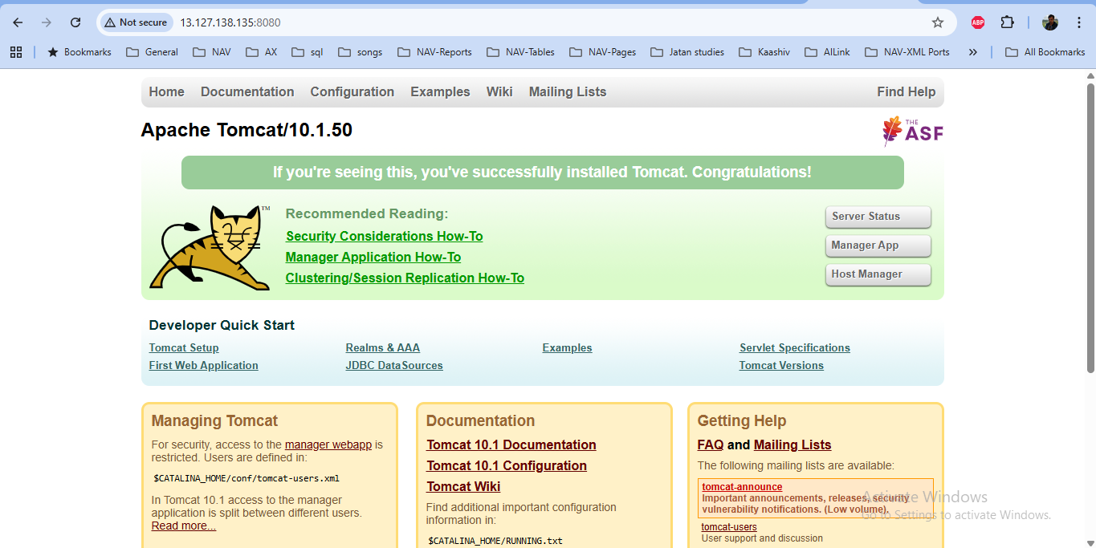
- Next go the slave server ec2 instance below the nano command used and change the value for access permission
[root@ip-172-31-13-188 ~]# nano /opt/apache-tomcat-10.1.50/webapps/manager/META-INF/context.xml
- Change the allow=”.*” or “0.0.0.0/0”
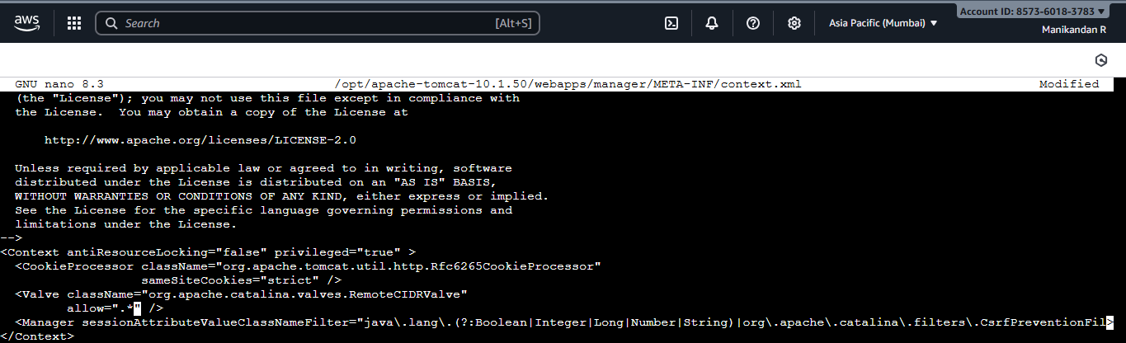

- Again add the nano command used and change the value for user access permission
[root@ip-172-31-13-188 ~]# nano /opt/apache-tomcat-10.1.50/conf/tomcat-users.xml
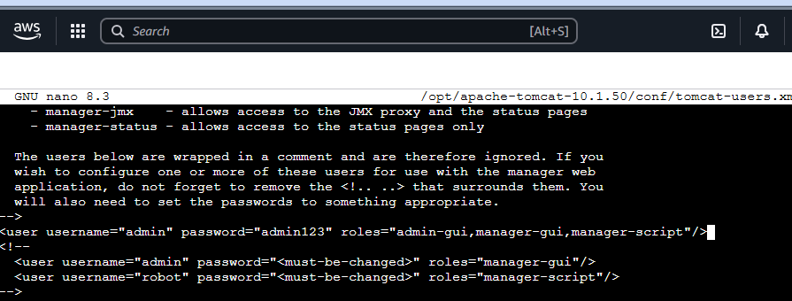
- Now copy the Public IP from server and run the http link format in browser
http://13.127.138.135:8080/
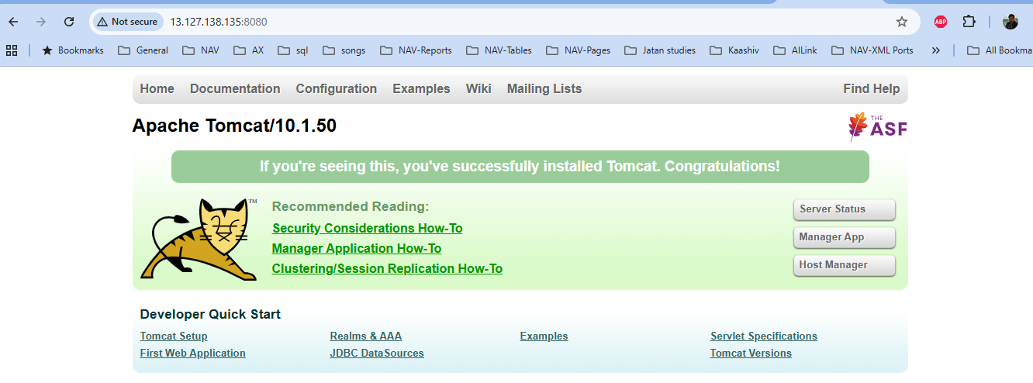
- Click Manage App button. Now asking username is admin and password is admin123 and click signin button.
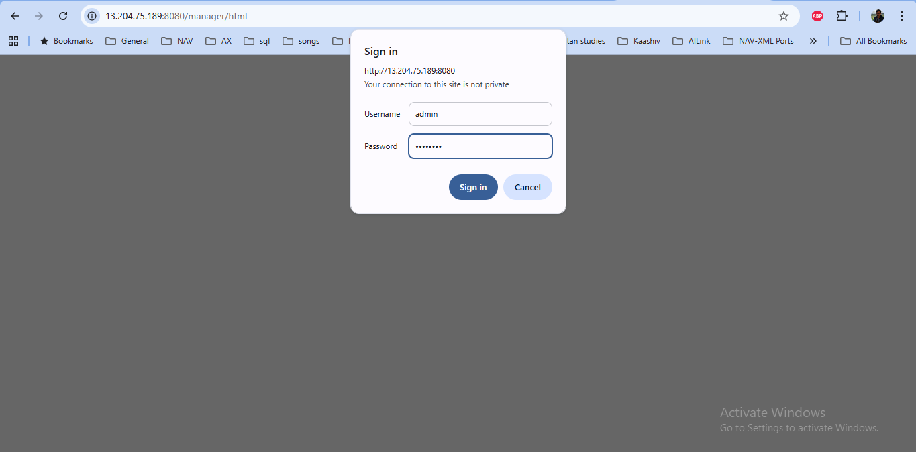
- Now tomcat web application manager page is open.
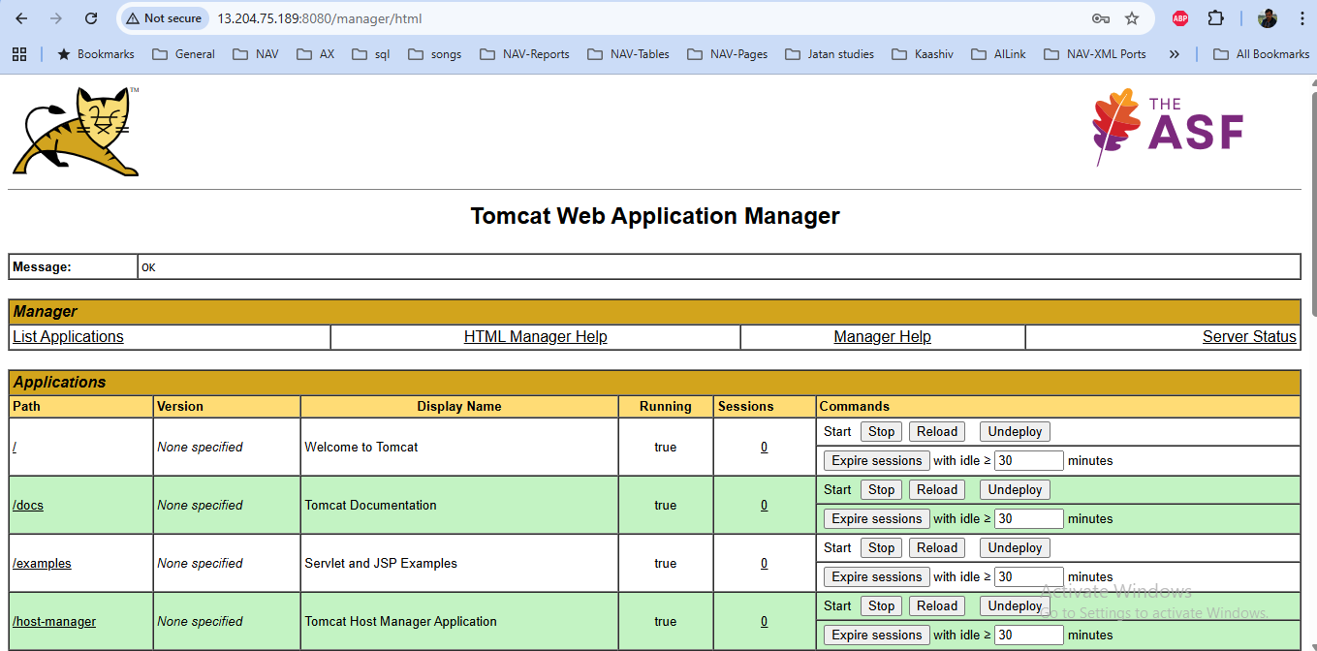
- Now Apache installation command
[root@ip-172-31-13-188 ~]# yum install httpd -y
- Set the reverse proxy. This configuration send the request, that request is automatically forward through the nano command
[root@ip-172-31-13-188 ~]# nano /etc/httpd/conf.d/proxypass.conf
- Now put below the code for reverse proxy
ProxyPass / http://localhost:8080/BlackGrapes/
ProxyPassReverse / http://localhost:8080/BlackGrapes/
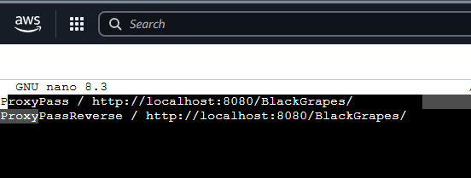
- Now restart the apache server
[root@ip-172-31-13-188 ~]# systemctl restart httpd
- Now Git installation command
[root@ip-172-31-13-188 ~]# yum install git -y
- This command the path of Git installation.
[root@ip-172-31-13-188 ~]# which git
/usr/bin/git
- Now Go to Jenkins-> Manage Jenkins->Tools
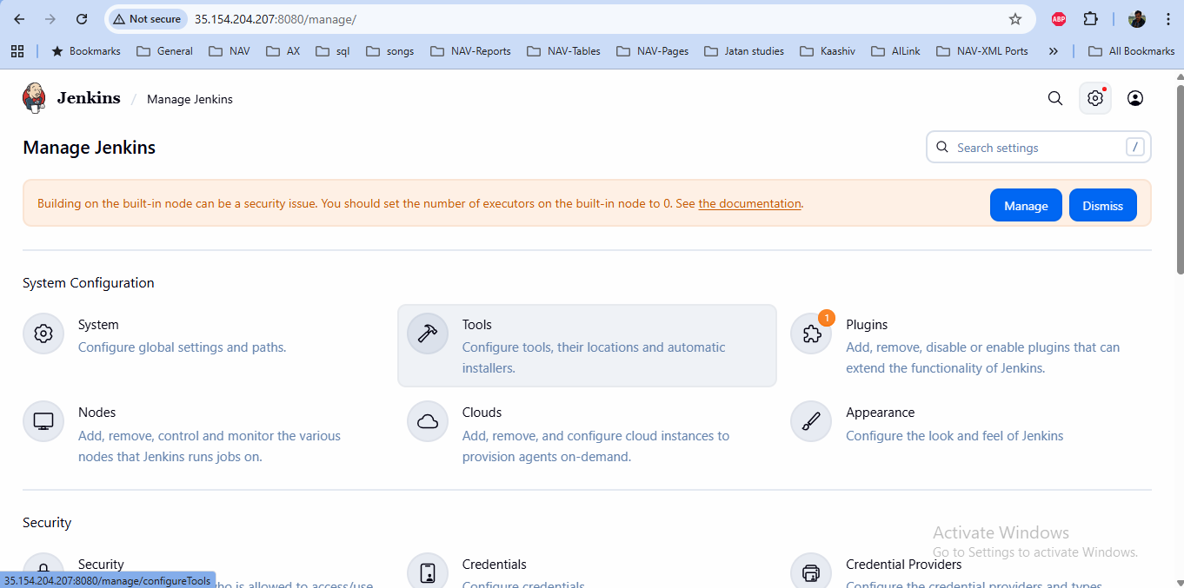
- Tools page is open. you choose the software installation path here. Above the Git installation path copy and paste here.
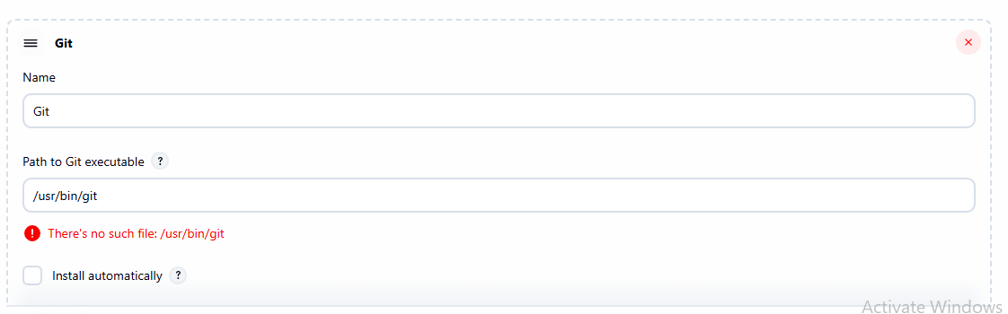
- Next maven installation path here. Previous I have set the maven environment path created. That path copy and paste it here without bin folder and then click save button.
/opt/apache-maven-3.9.12
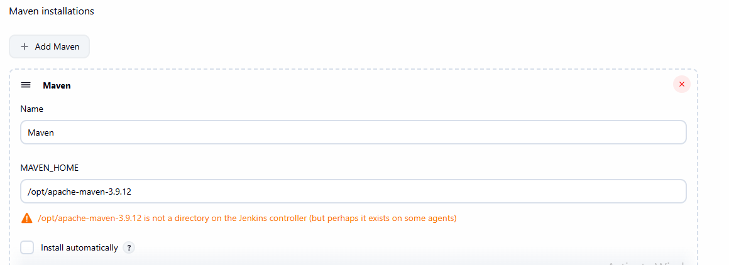
- Next setup the tomcat username and password in Jenkins. Manage Jenkins-> credentials
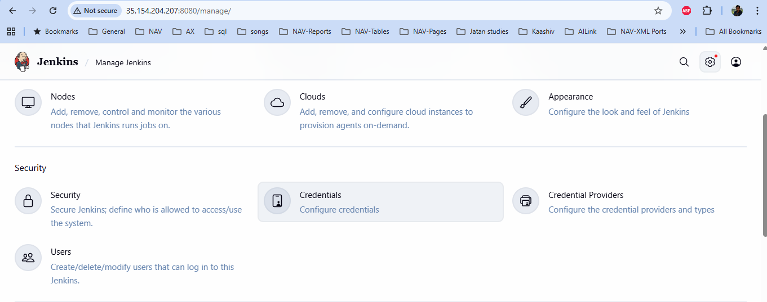
- Credentials is open. Click Globals->Add credentials
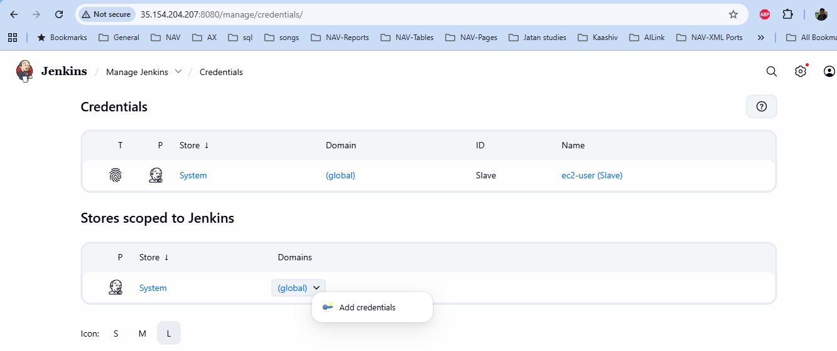
- Type admin in username
- Type admin123 in password.
- Type tomcat-user in ID
- Type tomcat-user in Description and click create button.
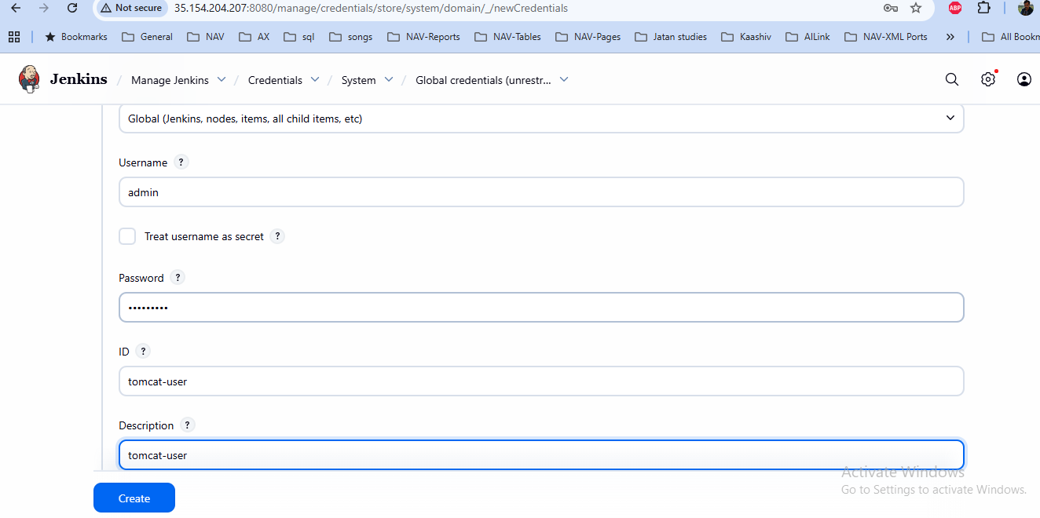
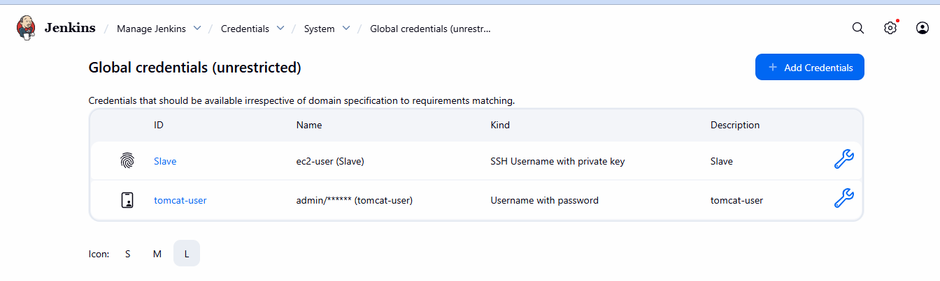
- Go to Manage jenkins-> click plugins.
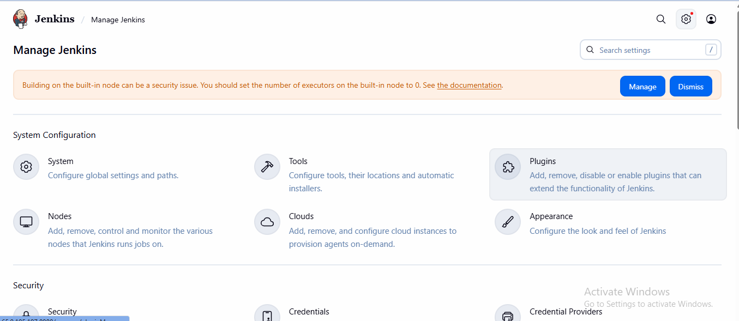
- Choose Available plugins in left Navigation bar. Type “deploy to container” in search available plugins. Choose the deploy to container option below and click install button
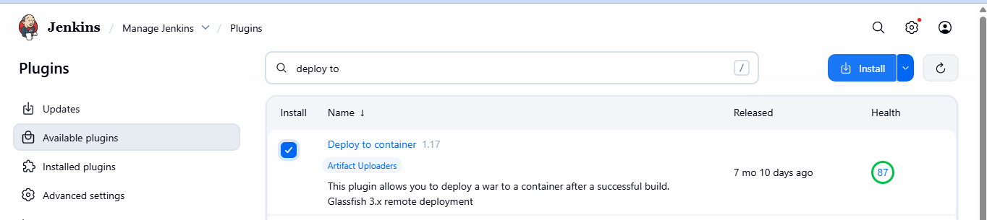
- After installation. Choose restart your Jenkins options. Now Jenkins is automatically restart and login again.
- Go to the github login. Open our project repository. My project repository is private. So I can generate the access token. In right top click Profile-> settings.
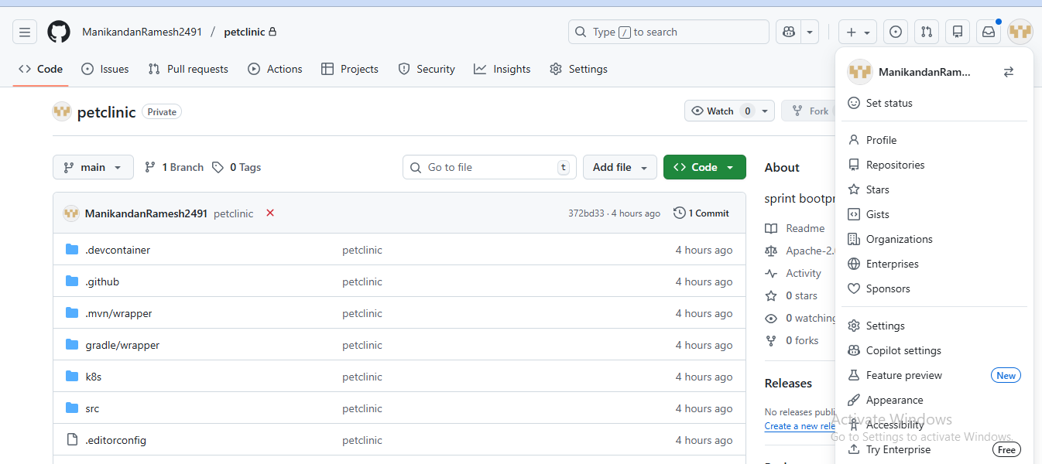
- Go down the navigation bar, Click developer settings.
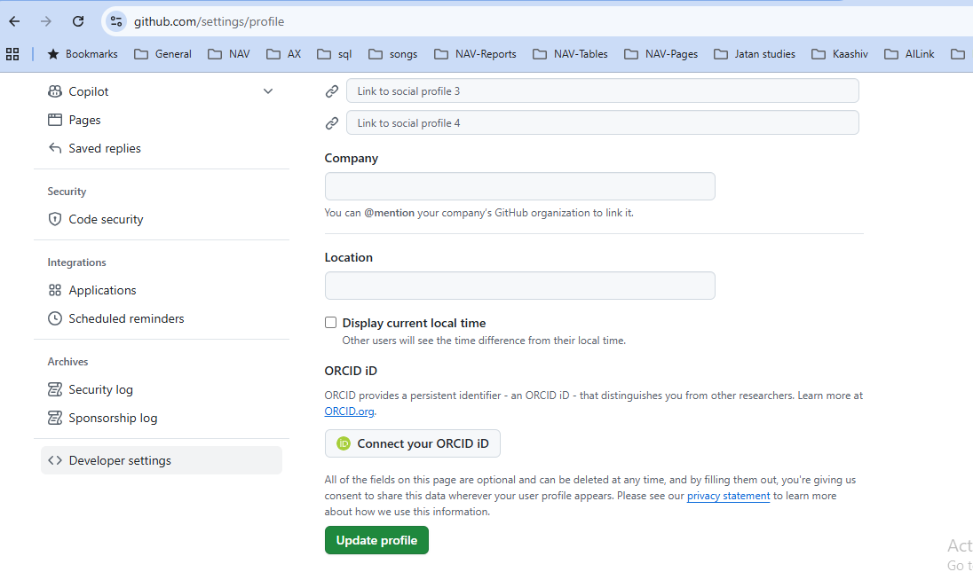
- Click personal access tokens-> tokens(classic). Click Generate new token button -> choose Generate new token(classic)
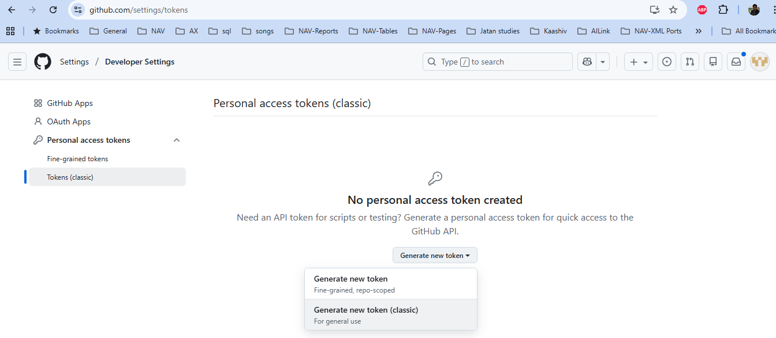
- Type the BlackGrapes in node.
- Choose repo, admin:repo_hook and click Generate Token button.
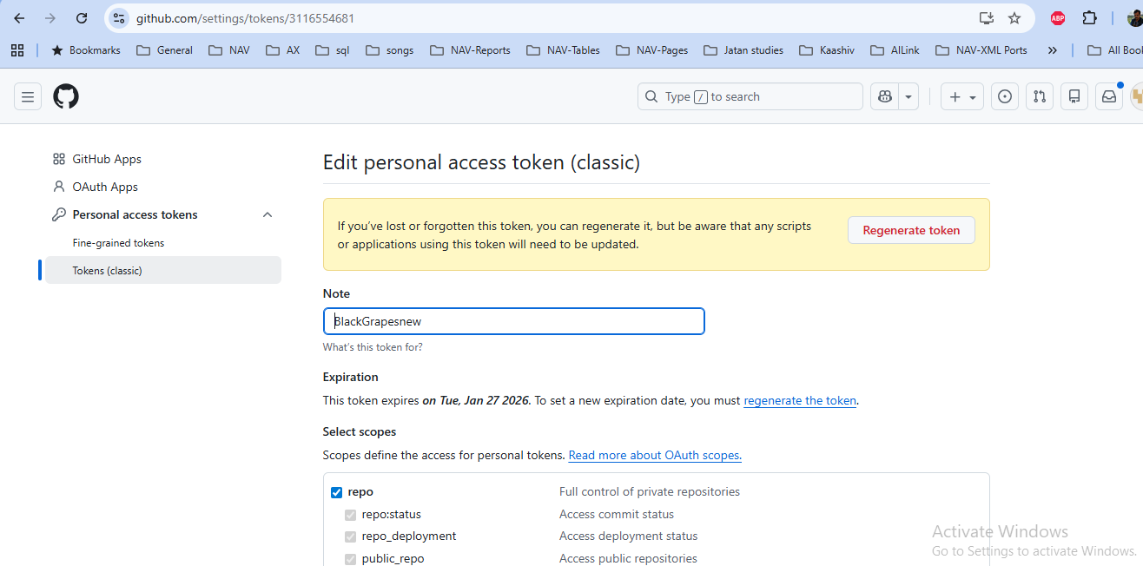
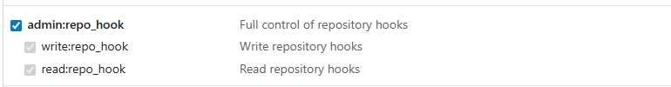
- Now token is generated
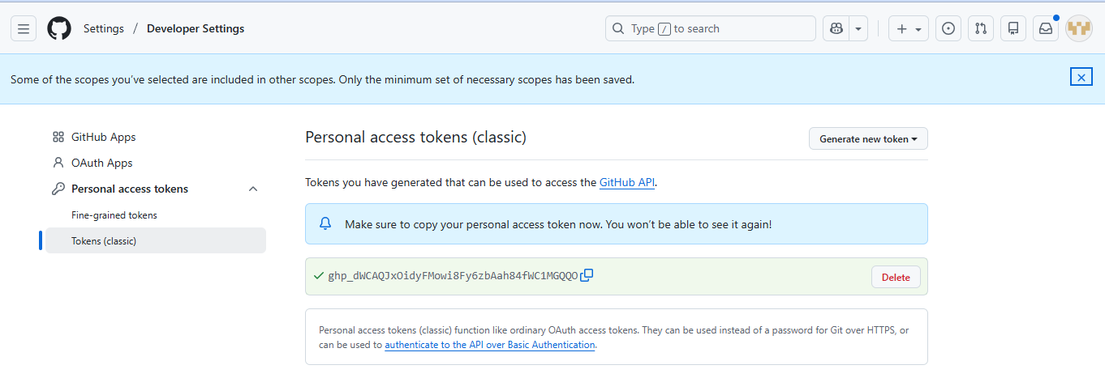

- Go to Jenkins dashboard Manage Jenkins ->Credentials is open. Click Globals->Add credentials

- Type ManikandanRamesh2491 in username. This value copy from our github account username.
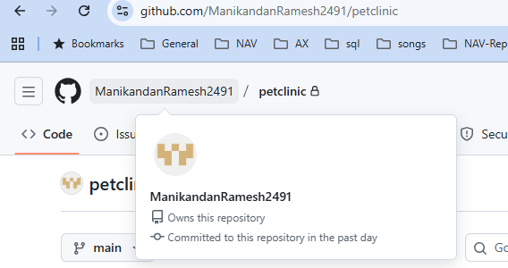
- Copy the classic token password and paste in password.
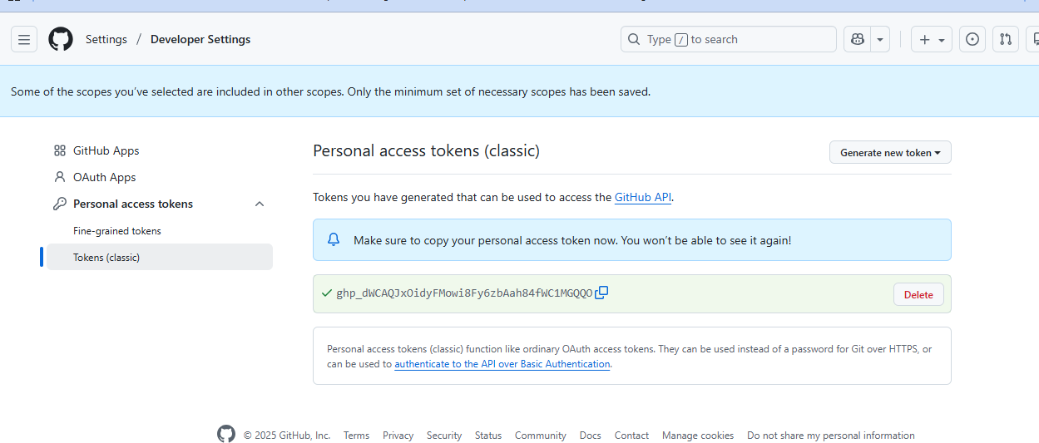
- Type Git-user in ID
- Type Git-user in Description and click create button.
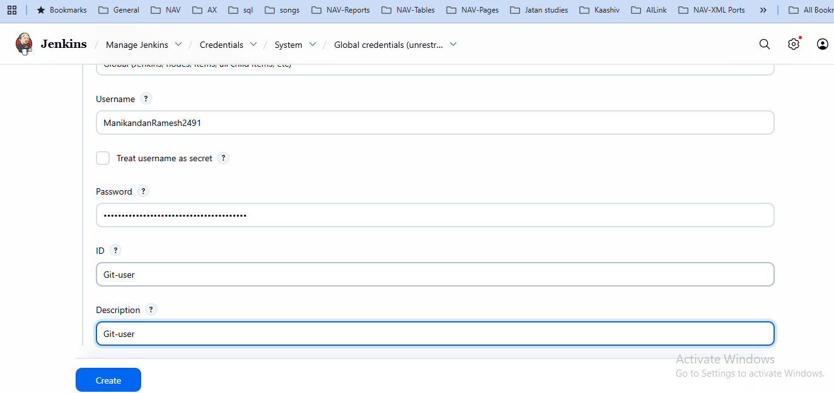

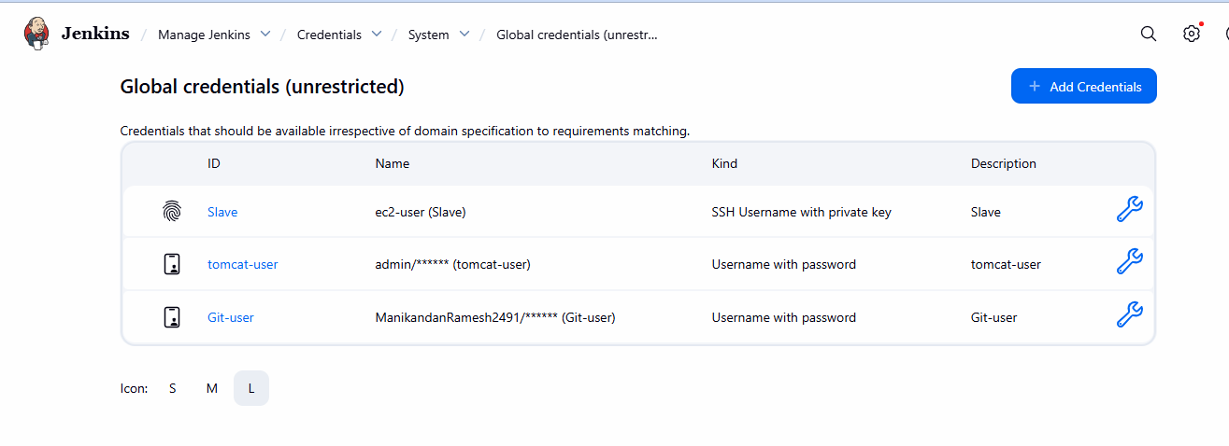
- Now I will create a new project. Click Jenkins dashboard -> click New Item
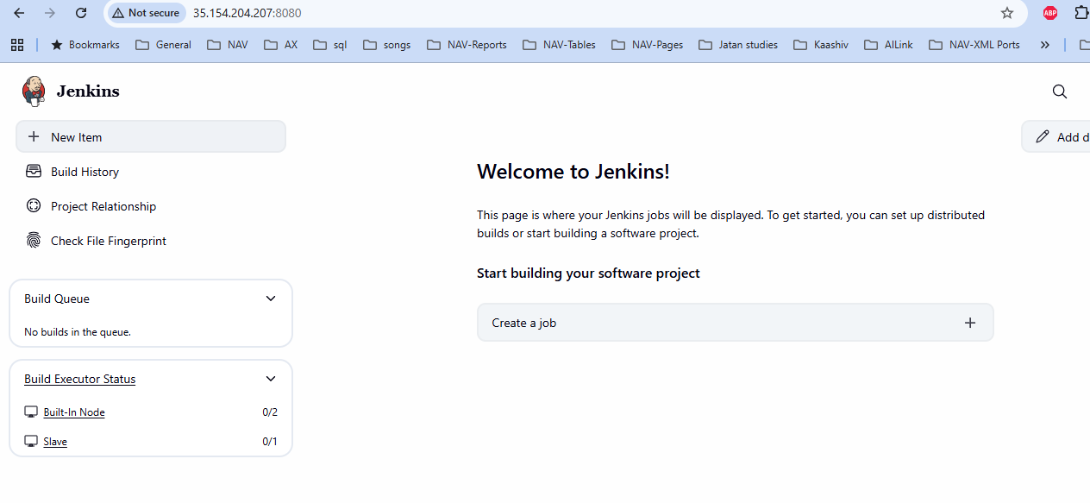
- Type the Sprintboot Maven (PL) in item name
- Choose the Pipeline project in item type and Click OK button
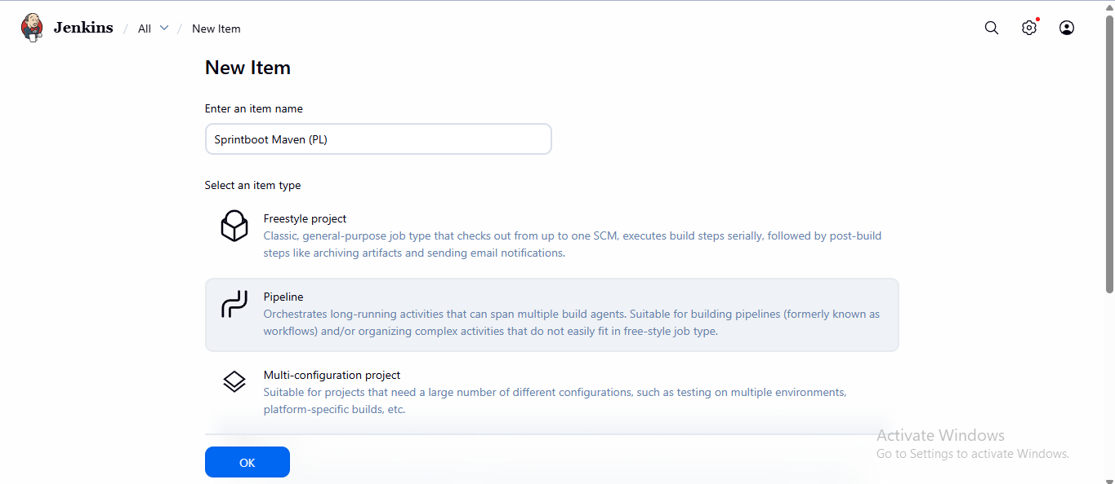
- Pipe line configure page is open. Choose pipeline in left navigation bar. Copy the pipeline script and paste it here.
- Type Maven under tools. This Maven name already assign in Manage Jenkins->tools, Here Maven installation and name generation “Maven-3.9.12”. Both the name will be same.
- Now copy the private ip from slave server and paste it under deploy to tomcat stage.
- Change the context path is BlackGrapes.
- Copy the our project url from github account and paste it under clone stage.

- Select Trigger navigation, Choose Poll SCM below type “H/2 * * * * “ and click outside. Every 2 minutes its automatically trigger with pipeline and github repository user changes
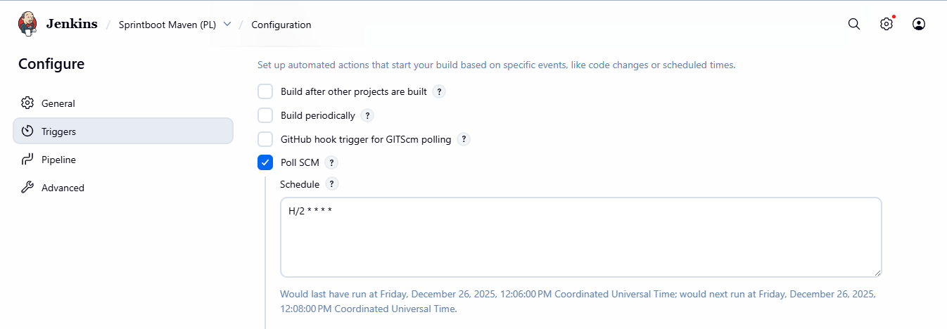

- Below pipeline code after changes
pipeline {
agent { label 'web-server' }

tools {
maven ' Maven-3.9.12'
}

stages {
stage('Clone') {
steps {
deleteDir()
git branch: 'main', credentialsId: 'Git-user’,url: 'https://github.com/ManikandanRamesh2491/BlackGrapes.git'
}
}

stage('Build & Test') {
steps {
sh 'mvn compile'
sh 'mvn package'
}
}

stage('Deploy to Tomcat') {
steps {
deploy adapters: [tomcat9(credentialsId: 'tomcat-user', url: 'http://172.31.1.88:8080')],
contextPath: 'BlackGrapes',
war: '**/*.war'
}
}
}
}

- After click save button. After click Build Now in left navigation bar
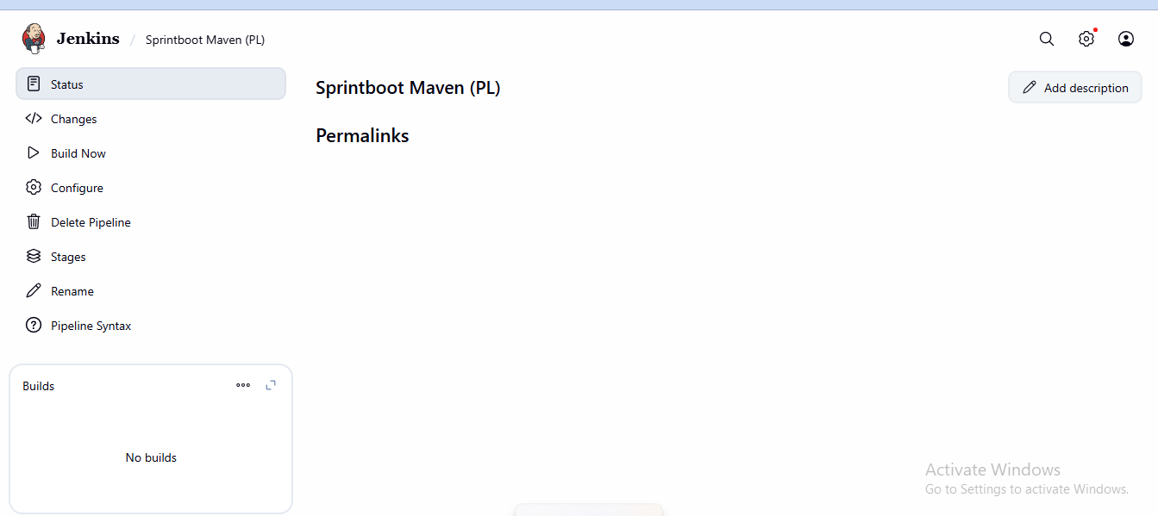

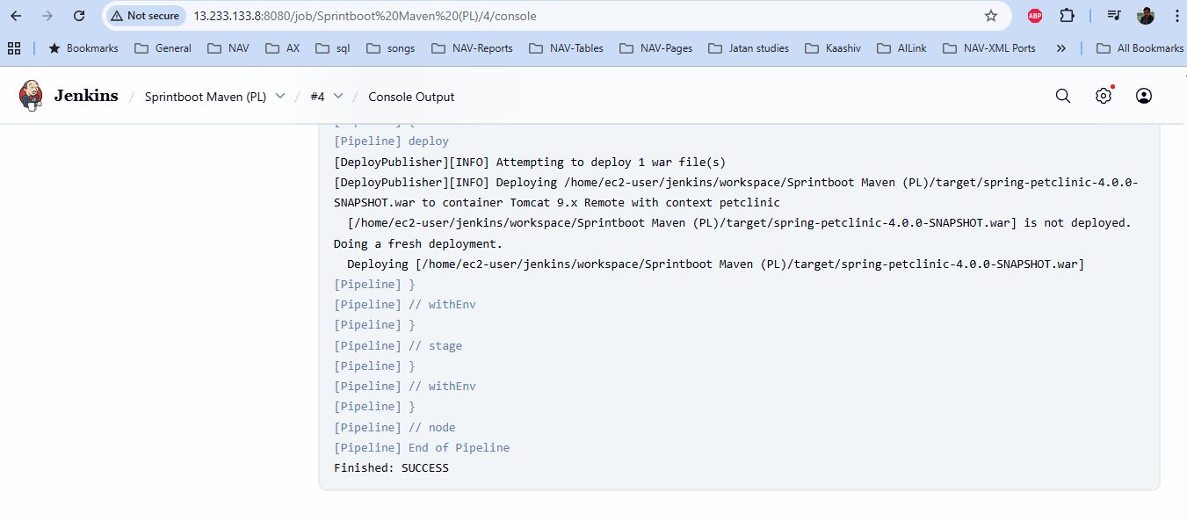
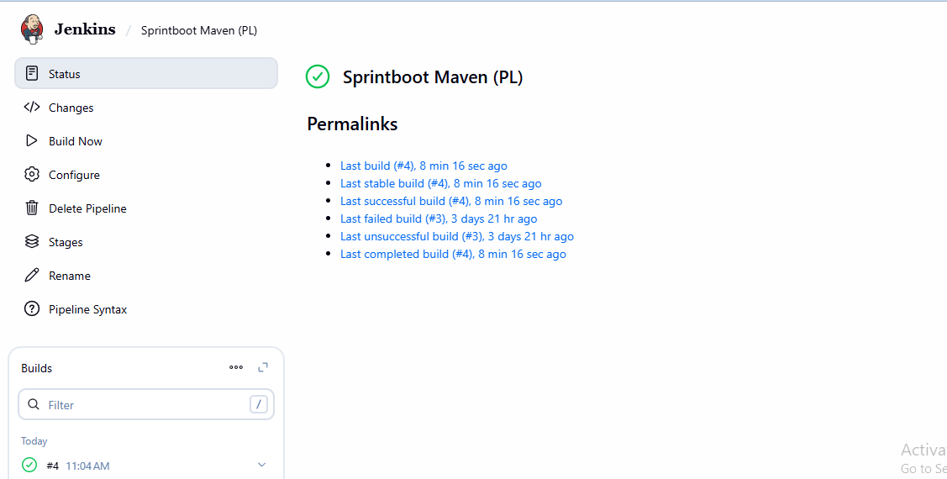
- Now click Stages in navigation bar.
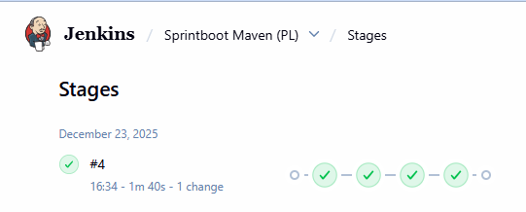
- Now copy and public IP and paste it in browser below the format. BlackGrapes path is created path column. Click the BlackGrapes path link. Now our project website will be open.
http://3.108.234.182:8080/manager/html
